**Grades**

Grades for U9, U10, U11 and U12. Birthdates to qualify for the age grades will be:

• U9 – born on or after 1 January 2013

• U10 – born on or after 1 January 2012

• U11 – born on or after 1 January 2011

• U12 – born on or after 1 January 2010

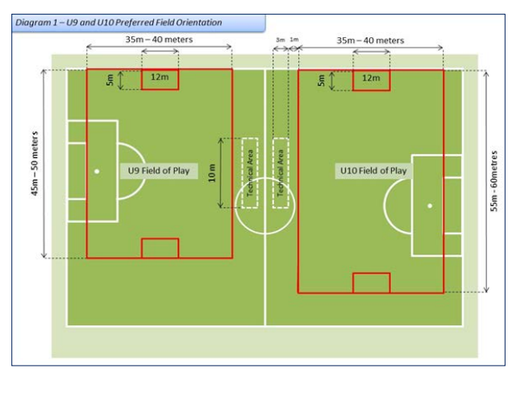

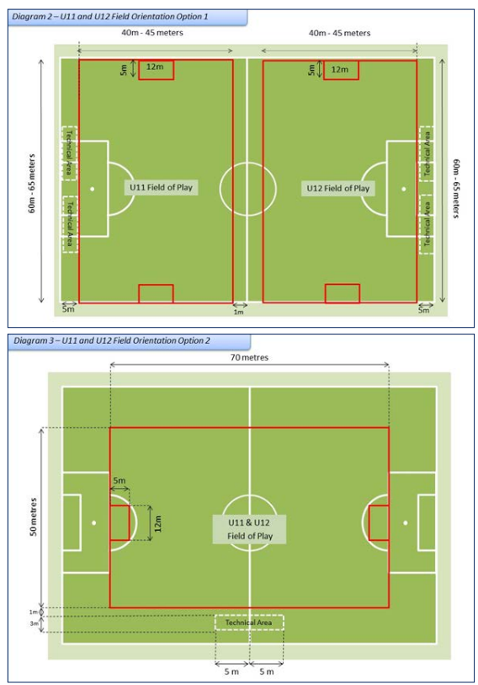

**Coaches**

**Mohammad Ali Al Helfy: U9 & U10**

**Hasan Saleh: U10 & U11 & U12**

**Mohammad Rahbarpour : U11 & U12**

**Time: 58-60 Melvin Street North, Beverly Hills**

**8:00-9:30 U9 & U10**

**9:30-10:50 U11 & U12**

**Time: Crisparkle Drive, Ambarvale**

**4:30: 6:00 U9 & U10 & U11 & U12D**

**Equipment to bring**

Playing shirt x 1

Playing short x 1

Playing socks x 1

Training shirt x 1

Training shorts x 1

Training socks x 1